**Assignment -3**

Python Programming

|  |  |
| --- | --- |
| Assignment Date | 19 September 2022 |
| Student Name | Gokul A |
| Student Roll Number | 810019104018 |
| Maximum Marks | 1. Marks |

1)What is 7 to the power of 4?

Solution:

pow(7,4)

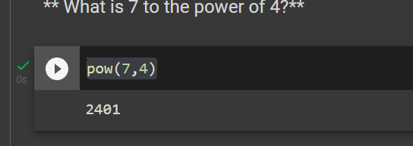

2)Split this string, into a list.

Solution:

s = "Hi there Sam!"

print(s.split())

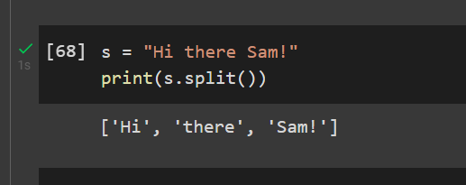

 3)Given the variables: Use .format() to print the following string:

planet = "Earth"  
diameter = 12742

Solution:

str="the diameter of {planet} is {diameter} kilometers.".format(planet="Earth", diameter=12742)

print(str)

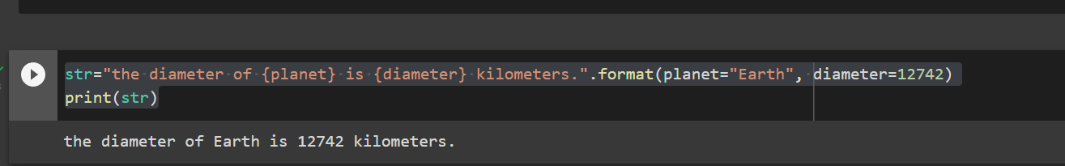

3)Given this nested list, use indexing to grab the word "hello"

Solution:

lst = [1,2,[3,4],[5,[100,200,['hello']],23,11],1,7]

lst[3][1][2][0]

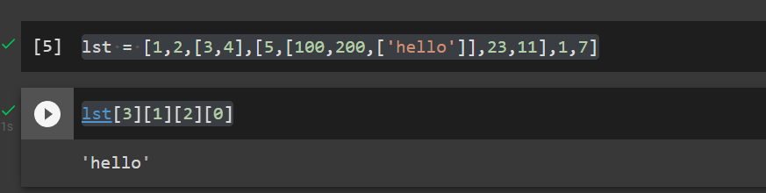

4) Given this nest dictionary grab the word "hello". Be prepared, this will be annoying/tricky

Solution:

d = {'k1':[1,2,3,{'tricky':['oh','man','inception',{'target':[1,2,3,'hello']}]}]}

d['k1'][3]['tricky'][3]['target'][3]

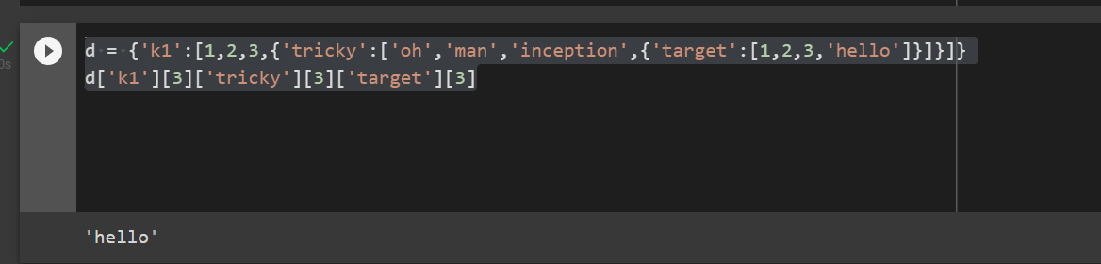

5)What is the main difference between a tuple and a list?

The list is dynamic, whereas the tuple has static characteristics.

6)Create a function that grabs the email website domain from a string in the form:

Solution:

def domainGet(email):

return email.split('@')[-1]

domainGet('user@domain.com')

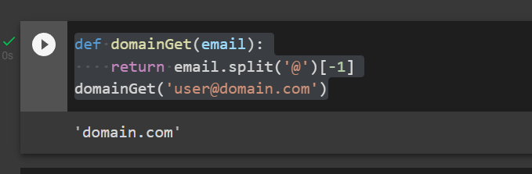

7)Create a basic function that returns True if the word 'dog' is contained in the input string. Don't worry about edge cases like a punctuation being attached to the word dog, but do account for capitalization.

Solution:

def findDog(st):

return 'dog' in st.lower().split()

findDog('dog have gratitude')

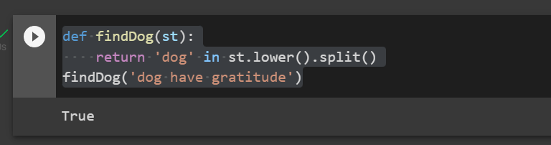

8)Create a function that counts the number of times the word "dog" occurs in a string. Again ignore edge cases.

Solution:

input=" doggle"

n=len(input)

count=0

for i in range(0,n,1):

if(input[i]=='d'):

if(input[i+1]=='o' and input[i+2]=='g'):

count+=1

else:

continue

print ("the count is:",count)

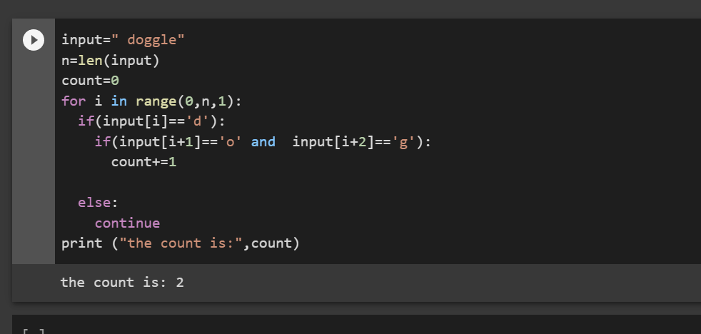

9)You are driving a little too fast, and a police officer stops you. Write a function to return one of 3 possible results: "No ticket", "Small ticket", or "Big Ticket". If your speed is 60 or less, the result is "No Ticket". If speed is between 61 and 80 inclusive, the result is "Small Ticket". If speed is 81 or more, the result is "Big Ticket". Unless it is your birthday (encoded as a boolean value in the parameters of the function) -- on your birthday, your speed can be 5 higher in all cases.

Solution:

def caught_speeding(speed, is_birthday):

if is_birthday:

speeding = speed - 5

else:

speeding = speed

if speeding > 80:

return 'Big Ticket'

elif speeding > 60:

return 'Small Ticket'

else:

return 'No Ticket'

caught_speeding(81,False)

caught_speeding(81,True)

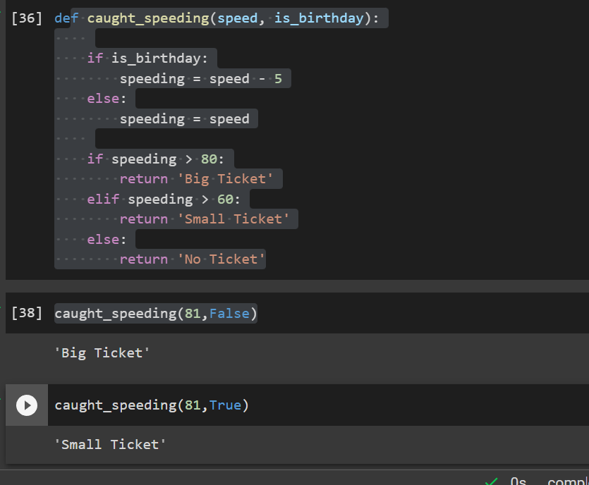

10)Create an employee list with basic salary values(at least 5 values for 5 employees) and using a for loop retreive each employee salary and calculate total salary expenditure.

Solution:

emp_salary=[12000, 5000, 50000,10000, 13000]

n= len(emp_salary)

salary=0

for i in range (0,n,1):

print (emp_salary[i])

salary+= emp_salary[i]

print("Total salary expenditure:",salary)

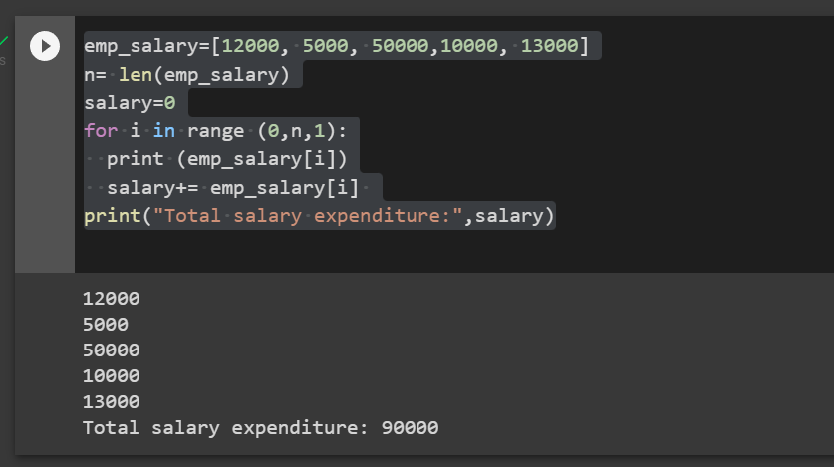

11)First one to contain fields as Empid, Empname, Basicpay

Second dictionary to contain fields as DeptName, DeptId.

Combine both dictionaries.

Solution:

dict1={ "empid": 1, "empname":"Kaadu", "basicpay":15000}

dict2={"deptname":"IT", "deptid":"D001"}

dict2.update(dict1)

print(dict2)

